

GOVERNMENT OF PAKISTAN
BIDDING DOCUMENTS

SERVICES OF EXHIBITION BOOTH CONSTRUCTION COMPANY FOR EXHIBITORS FROM PAKISTAN AT WORLD HEALTH EXPO OR MAGIC 2026 IN Las Vegas, USA
(10TH August 2026- 12TH August 2026)
July 6, 2026
Consulate General of Pakistan
11850 Jones Road, Houston Zip Code 77070

Invitation for Bids & General Terms and Conditions

SERVICES OF EXHIBITION BOOTH CONSTRUCTION COMPANY FOR EXHIBITORS FROM PAKISTAN AT LAS VEGAS CONVENTION CENTER IN LAS VEGAS, USA
The Trade Development Authority of Pakistan (TDAP) and the Ministry of Commerce (MoC) have decided to participate in the MAGIC Las Vegas as part of TDAP's annual business plan. Around 48 companies are expected to participate in the MAGIC Las Vegas 2026, facilitated and sponsored by the Trade Development Authority of Pakistan, from 10th August to 12th August 2026. The MAGIC Las Vegas 2026 will be a three-day event. Pakistani exhibitors will showcase the quality of Pakistan's products. On the sidelines of the leading exhibition, B2B meetings and G2G meetings will take place mainly in the Health Care Sector.
2. The exhibition booth/stall construction company would be required to manage the three-day event stall construction and provide all the necessary services (as directed by TDAP, MoC, and Trade Wing-Houston) at the Las Vegas Convention Center, Las Vegas, USA. Terms of reference for the three-day events are detailed on all event components. There will be no compromise on the quality and services described in the Billing of Quantity (BOQ) Section.
3. Bidding documents and other related information for the purpose can be obtained on written request from the Consulate General of the Islamic Republic of Pakistan, Houston, USA (address given below) or can be downloaded from the website of the Consulate General of the Islamic Republic of Pakistan, Houston, USA. To avoid confusion, the firm will submit its sealed Technical Proposals and Financial Proposal in bold and legible letters.
4. Financial proposals should accompany a bid security declaration form attached at the end of the document.
5. Single Stage One Envelope Procedure would be used to Open Competitive Bidding. (PPRA Rules 2024, Pakistan)
6. Sealed tender documents shall be submitted by 24th July 2026 at noon CST USA with the Trade Commission of Pakistan, Houston, and Technical Proposals shall be opened by the Tender Committee on the same day at 01:00 P.M. CST USA in the presence of representatives of the participating firms, if any. The technical evaluations will be posted on the Public Procurement Regulatory Authority (PPRA) websites for fourteen (14) days. The proposal from the lowest bidder will be accepted if it meets all the requirements mentioned in the tender documents. The hoisting of financial bids at the PPRA website (per PPRA rules) will be done before the tender is awarded.
7. The Trade Development Authority of Pakistan (TDAP), the Ministry of Commerce (MOC), and the Tender Committee reserve the right to reject any or all bids and to annul the bidding process at any time. However, the Procurement Rules will communicate the reasons for refusing or revoking the bid process to the concerned bidder (s).
Consulate General of the Islamic Republic of Pakistan, Houston
11850 Jones Road, postal code 77070
Email: pakcom.hus@tdap.gov.pk

Table of Contents
General Terms and Conditions 3
A. Preparation of Bid 3
B. Preparation of Bid and Award of Tender: 3
1. Documents Comprising the Bid 3
A Technical Proposal 3
Financial Bid 4
2. Bid Form 4
3. Bid Prices 4
4. Bid Currencies 4
5. Documents Establishing Bidder’s Eligibility and Qualification 4
6. Bid Security 5
7. Period of Validity of Bids 5
8. Format and Signing of Bid 5
B. Submission of Bids 6
9. Sealing and Marking of Bids 6
10. Deadline for Submission of Bids 6
11. Late Bids 6
12. Modification and Withdrawal of Bids 7
C. Opening and Evaluation of Bids 7
13. Opening of Bids by the Procuring agency 7
14. Clarification of Bids 7
15. Preliminary Examination 8
16. Evaluation and Comparison of Bids 8
17. Contacting the Procuring agency 8
D. Award of Contract 9
18. Post qualification 9
19. Award Criteria 9
20. Procuring agency’s Right to Vary Quantities at Time of Award 9
21. Procuring agency’s Right to accept any Bid and to reject any or All Bids 10
22. Notification of Award 10
23. Signing of Contract 10
SECTION II: Bid Data Sheet 11
Payment for Services & Goods supplied: 11
SECTION III. Schedule of Requirements/ Terms of Reference 12
BOQ for MAGIC Las Vegas (10th August - 12th August,2026) 12
Technical Criteria for Selection of exhibition booth construction company for MAGIC Las Vegas (10th August - 12th August 2026) 12
Bid-Securing Declaration 14
[The Bidder shall fill in this Form following the instructions indicated.] 14

General Terms and Conditions

A. Preparation of Bid
Single Stage One Envelope (Technical and Financial Bids).

B. Preparation of Bid and Award of Tender:
The bidders must submit their bid in one envelope, separately marked as Technical Proposal and Financial Proposal. Initially, the bidder's technical proposal shall be opened. If the same is found to be responsive as per the Tender Terms, the financial proposal of a technically responsive bidder shall be opened. The tender shall be awarded based on the low cost of the financial proposal and subject to conformity with the tender requirements (technical and financial).

1. Documents Comprising the Bid

1.1 The bid prepared by the Bidder shall comprise the following components:

A Technical Proposal
Comprising a Cover letter, Company Profile, work experience & Financial Strength, and a proposal on a work plan based on the Schedule of Requirements/ TORs. The Bidder should take into consideration the parameters listed in the Technical Evaluation Criteria for submission of the Technical Proposal as described in the bidding documents.
The technical criterion is given in Annex A.
The technically responsive bidder must obtain at least 70% marks in the technical requirements.
Any Bidder unable to provide all documents mentioned in the technical criteria will not be entertained, but will be allowed to do so with the approval of the Tender (Evaluation) Committee.

Financial Bid
The financial proposal shall comprise a Bid Form and a Price Schedule completed by the mentioned columns and
Bid security is furnished following the rules.
Bidders must submit the cost/rate against each requirement.

2. Bid Form

2.1 The Bidder shall complete the Bid Form and the appropriate Price Schedule furnished in the bidding documents, indicating the goods/ services to be supplied and a brief description of the goods, quantity, and prices.

3. Bid Prices

3.1 The Bidder shall indicate on the appropriate Price Schedule the unit prices (where applicable) and total bid price of the services & goods it proposes to supply under the contract.
3.2 Unless otherwise stipulated in the Conditions of Contract, prices quoted by the bidder shall remain fixed during the bidder’s performance of the Contract and not be subject to variation on any account. The cost of other (incidental) services, if any, will be increased separately.
3.3 Prices quoted by the Bidder shall be fixed during the Bidder’s contract performance and not subject to variation on any account unless otherwise specified in the Bid Data Sheet.

4. Bid Currencies
4.1 Prices may be quoted in dollars.

5. Documents Establishing Bidder’s Eligibility and Qualification
5.1 The Bidder shall furnish, as part of its bid, documents establishing the Bidder’s eligibility to bid and its qualifications to perform the contract if its bid is accepted.
5.2 The documentary evidence of the Bidder’s eligibility to bid shall establish to the Procuring agency’s satisfaction that the Bidder is legally established and has worked in the Event organization sector in the USA at the time of submission of its bid. The bidder may have worked as an organizer in an international trade exhibition for at least three years.
5.3 The documentary evidence of the Bidder’s qualifications to fulfill the contract, if its bid is accepted, shall have to be established to the Procuring agency’s satisfaction:

- Bidder/Manufacturer/contractors must possess and provide evidence of their capability, experience, and qualification criteria as stipulated in the Bidding Documents and Bid Data Sheet.
- that the Bidder has the financial and technical capability necessary to perform the contract.
- Bidders having a Joint Venture can participate and be treated as a single bidder

6. Bid Security

6.1 Bidder shall furnish, as part of its bid, a bid declaration form as attached in this document and attach it to the submitted bid during bid submission as part of the technical bid.
6.2 The bid declaration is required to protect the Procuring agency against the risk of the Bidder’s conduct, which would warrant the security’s forfeiture, pursuant to conditions mentioned in the bid.
6.4 The Procuring agency will reject any bid not secured by the above as non-responsive.
6.6 The triumphant Bidder’s bid declaration will be discharged upon the Bidder signing the contract and furnishing the performance security.

7. Period of Validity of Bids
7.1 Bids shall remain valid for 05 months/ or till MAGIC Las Vegas 2026 as specified in the Bid Data Sheet after the date of bid opening prescribed by the Procuring agency. The Procuring agency shall reject a bid valid for a shorter period as nonresponsive.
7.2 In exceptional circumstances, the Procuring agency may solicit the Bidder’s consent to an extension of the validity period. The request and the responses thereto shall be made in writing. A Bidder may refuse the request without any claims through the Bid Security Declaration. A Bidder granting the request will not be required nor permitted to modify its bid except as provided in the bidding document.

8. Format and Signing of Bid

8.1 The original bid shall be typed or written in indelible ink and shall be signed by the Bidder or a person or persons duly authorized to bind the Bidder to the contract. Considering the nature of the event for international tendering, electronic emails from the company account, duly signed /scanned or digitally signed, are acceptable.
8.2 When Applicable: Any interlineations, erasures, or overwriting shall be valid only if initialized by the person or persons signing the bid.

B. Submission of Bids

9. Sealing and Marking of Bids
9.1 The Bidder shall seal the Technical and Financial Bids, if electronic, may be signed digitally and sent through official email or company email bearing the company registration number and documents indicating validity. If there is an envelope, the envelopes shall then be sealed in an outer envelope.
9.2 The inner and outer envelopes shall:
(a) be addressed to the Consulate General of Pakistan Houston 11850 Jones Road, Zipcode 77070 Houston USA or email: Pakcom.hus@tdap.gov.pk
(b) Bear the Project name indicated in the Bid Data Sheet, the Invitation for Bids (IFB) title and number shown in the Bid Data Sheet, and a statement: “DO NOT OPEN BEFORE,” to be completed within the time and the date specified in the Bid Data Sheet.
9.3 The inner envelopes shall also indicate the name and address of the Bidder to enable the bid to be returned unopened in case it is declared “late.”
9.4 If the outer envelope is not sealed and marked as required, the Procuring agency will assume no responsibility for the bid’s misplacement or premature opening.
9.5 Bids submitted through telegraph, telex, fax, shall not be considered
9.6 Bids submitted through email are acceptable only in case of directly sent to pakcom.hus@tdap.gov.pk.

10. Deadline for Submission of Bids
10.1 The Procuring agency must receive bids at the address specified no later than the time and date specified in the Bid Data Sheet.

11. Late Bids
11.1 Any bid received by the Procuring agency after the deadline for submission of bids prescribed by the Procuring agency will be rejected and returned unopened to the Bidder.

12. Modification and Withdrawal of Bids
12.1 The Bidder may modify or withdraw its bid after the bid’s submission, provided that written notice of the modification, including substitution or withdrawal of the bids, is received by the Procuring agency before the deadline for submission of bids.
12.2 The Bidder’s modification or withdrawal notice shall be prepared, sealed, marked, and dispatched by the provisions by a signed confirmation copy, postmarked no later than the deadline for submission of bids.
12.3 No bid may be modified after the deadline for submission of bids.
12.4 No bid may be withdrawn between the deadline for submission of bids and the expiration of the bid validity period specified by the Bidder on the Bid Form. Withdrawal of a bid during this interval may result in the Bidder’s forfeiture of its bid security. If the bidder or his/her representative does not appear at the opening of the financial bid, the bid may be canceled.

C. Opening and Evaluation of Bids

13. Opening of Bids by the Procuring agency
13.1 The Procuring agency (procurement committee/Tender Committee) will open all bids with bidders’ representatives who choose to attend at the time (Not Mandatory), on the date, and at the place specified in the Bid Data Sheet. The present bidders' representatives shall sign an attendance sheet evidencing their attendance.
13.2 The bidders’ names, bid modifications or withdrawals, bid prices, discounts, and the absence of requisite bid security and such other details as the Procuring agency, at its discretion, may consider appropriate, will be announced at the opening. No bid shall be rejected at bid opening, except for late bids, which shall be returned unopened to the Bidder.
13.3 Bids not opened and read out at bid opening shall not be considered further for evaluation, irrespective of the circumstances. Withdrawn bids will be returned unopened to the bidders.
13.4 The Procuring agency will prepare minutes of the bid opening.

14. Clarification of Bids
14.1 During the evaluation of the bids, the Procuring agency may, at its discretion, ask the Bidder to clarify its bid. The request for clarification and the response shall be in writing, and no change in the prices or substance of the bid shall be sought, offered, or permitted. The bidder can also contact the Procurement agency/procurement committee/tender committee or Consulate General of the Islamic Republic of Pakistan, Houston, USA, for clarification.

15. Preliminary Examination
15.1 The Procuring agency/procurement committee/tender committee will examine the bids to determine whether they are complete, whether any computational errors have been made, whether required sureties have been furnished, whether the documents have been properly signed and whether the bids are generally in order.
15.2 Arithmetical errors will be rectified on the following basis. If there is a discrepancy between the unit price and the total price obtained by multiplying the unit price and quantity, the unit price shall prevail, and the total price shall be corrected. If the Supplier does not accept the correction of the errors, its bid will be rejected, and its bid security may be forfeited. If there is a discrepancy between words and figures, the bidder must clarify the amount.
15.3 The Procuring agency/procurement committee/tender committee may waive any minor informality, nonconformity, or irregularity in a bid that does not constitute a material deviation, provided such waiver does not prejudice or affect the relative ranking of any Bidder.
15.4 Before the detailed evaluation, the Procuring agency will determine the substantial responsiveness of each bid to the bidding documents. For purposes of these Clauses, a substantially responsive bid conforms to all the terms and conditions of the bidding documents without material deviations. Deviations from, or objections or reservations to critical provisions, such as those concerning Bid Security, Applicable Laws, and Taxes and Duties, will be deemed a material deviation. The Procuring agency’s determination of a bid’s responsiveness is to be based on the contents of the bid itself without recourse to extrinsic evidence.
15.5 If a bid is not responsive, it will be rejected by the Procuring agency and may not subsequently be made responsive by the Bidder by correcting the nonconformity.

16. Evaluation and Comparison of Bids
16.1 The Procuring agency will evaluate and compare the bids that have been determined to be substantially responsive.
16.2 Technically responsive Bids will be evaluated for the complete scope of work. The prices will be compared based on the Evaluated Bid Price pursuant to the following:
(a) Evaluation of Financial Bid
The bids will be examined in detail to determine whether they comply with the commercial/contractual conditions of the Bidding Documents. It is expected that the bidders shall take no material deviation/stipulation. The Procuring agency’s bid evaluation will be on delivered duties/ taxes paid.

17. Contacting the Procuring agency

17.1 No Bidder shall contact the Procuring agency on any matter relating to its bid from the time of the bid opening to the time the contract is awarded. If the Bidder wishes to bring additional information to the notice of the Procuring agency, it should do so in writing.
17.2 Any effort by a Bidder to influence the Procuring agency in its decisions on bid evaluation, bid comparison, or contract award may result in the rejection of the Bidder’s bid.

D. Award of Contract

18. Post qualification
18.1 post-qualified bidders will move to financial bidding. The lowest bidder in the financial bidding process will be considered for the contract award as per TORs and the contract agreement in this tender. The letter of Award will be issued to the prospective bidder after evaluating the financial bid. In case of non-responsive for 07 days, the bid will be rejected, and the award letter will be issued to the second lowest bidder.
18.2 The determination will consider the Bidder’s financial and technical capabilities. It will be based upon examining the documentary evidence of the Bidder’s qualifications submitted by the Bidder and other information as the Procuring agency deems necessary and appropriate.
18.3 An affirmative determination will be a prerequisite for awarding the contract to the Bidder. An adverse determination will result in the rejection of the Bidder’s bid. In that event, the Procuring agency/procurement committee/tender committee will proceed to the next lowest evaluated bid to make a similar determination of that Bidder’s capabilities to perform satisfactorily.

19. Award Criteria
19.1 The Procuring agency, after the post-qualification process, will award the contract to the successful Bidder whose bid has been determined to be responsive and has been determined to be the lowest bid, provided further that the Bidder is determined to be qualified to perform the contract satisfactorily. A formal agreement will be signed between contracting parties with the TORs provided.

20. Procuring agency’s Right to Vary Quantities at Time of Award
20.1 The Procuring agency reserves the right at the time of contract award to increase or decrease, by the percentage indicated in the Bid Data Sheet, the number of goods and services initially specified in the Schedule of Requirements without any change in unit price or other terms and conditions.
20.2 The Procuring agency reserves the right at the time of contract award to increase or decrease, by 10%-15%, the quantity of goods and services initially specified in the Schedule of Requirements without any change in unit price or other terms and conditions.

21. Procuring agency’s Right to accept any Bid and to reject any or All Bids
21.1 The Procuring agency reserves the right to accept or reject any bid and to annul the bidding process and reject all bids at any time before contract award, without thereby incurring any liability to the affected Bidder or bidders and by provisions of Public Procurement Rules 2004.

22. Notification of Award

22.1 Before the bid validity period expires, the Procuring agency will notify the successful Bidder in writing by registered letter or by cable, to be confirmed in writing by registered letter, that its bid has been accepted.
22.2 The notification of the award will constitute the formation of the Contract.

23. Signing of Contract
23.1 When the Procuring agency notifies the successful Bidder that its bid has been accepted, the Procuring agency will send the Bidder the Contract Form provided in the bidding documents, incorporating all agreements between the parties.
23.2 Within seven (07) working days of receipt of the Contract Form or give consent as reply through proper channel or official email, the successful Bidder shall sign and date the contract and return it to the Procuring agency/procurement committee/tender committee or Pakistan Consulate General Houston, USA.

SECTION II: Bid Data Sheet

The following specific data for the goods to be procured shall complement, supplement, or amend the provisions in the Instructions to Bidders (ITB) Part One. The provisions herein shall prevail over those in ITB during a conflict.

Preparation and Submission of Bids
Bid Declaration Form | This is to be submitted as per the format provided with the bid submission.
Documents copies | One copy
Bid addressed to | Consulate General of Islamic Republic of Pakistan, Houston, USA  11850 Jones Road, Zipcode 77070 Houston, USA
Subject title | Invitation for Bids & General Terms and Conditions  Services of exhibition booth construction company for exhibitors from Pakistan at MAGIC Las Vegas in Las Vegas, USA
Date of issue | 6th July, 2026
Date of Submission

Payment for Services & Goods supplied:
Payment shall be made in Dollars in the following manner:
- Advance Payment after facility confirmation will be applicable in case of formal contract signing. Payment will be made within 20 days after the successful completion of Magic Las Vegas 2026. A deduction for substandard services or any other related matter will be decided by the Trade and Investment Attache as per the reviews of the exhibitors, if any, with details.

SECTION III. Schedule of Requirements/ Terms of Reference

BOQ for Magic Las Vegas (10th August - 12th August,2026)

S.No | DESCRIPTION | Quantity | Unit Rate (Dollar) | Total Amount (Dollar)
1 | EXHIBITION BUILD-UP (Mock Design) (At Annexure 1)  - Complete customized shell scheme for 40 exhibitors for a 10x10 ft booth. Perforated hardback & side walls, 1 Table & 3 Chairs, one counter glass showcase, 4 Track lights, Company Name ID and Logo on Counter Front, Waste bin, Carpet, 4 Hanging Rods, 4 Shelves, 100 Hooks, 70 Top Hangers, 30 Bottom Hangers, Electricity, Backlight Fascia, Graphics on panel and branding of Pakistan as shown in the following photos, Cleaning. Installation/Dismantling of booth with One time Cleaning. Material Handling and Labor Included.
Compliance with Safety and all other related regulations of the Las Vegas Convention Center for Magic Las Vegas 2026 is mandatory.

Technical Criteria for Selection of exhibition booth construction company for Magic Las Vegas (10th August - 12th August 2026)

 | Parameters against which technical evaluation shall be done | Scoring brackets | Total points allocated
1 | Company Profile |  | 25
1.1 | Years in Exhibition Management Business:
 | >1 year | 0
 | < 2 years | 5
 | > 3 < 4 years | 8
 | > 5 < 7 years | 10
1.2 | International Affiliations & prior Experience of FIME:
 | No affiliations or certifications with international associations in the field and certifying agencies. No experience of FIME | 0
 | General affiliations and certifications are only those unrelated to exhibition management, such as ISO. | 3
 | Certifications + Experience of Booth Construction in FIME less than 1 year | 10
 | Experience in Stall Construction in FIME for more than two years | 15
2 | Relevant Experience |  | 30
2.1 | Construction and Managing Exhibitions
 | < 1 | 5
 | > 3 < 10 | 15
2.2 | Past experience of Booth Construction in the US
 | > 2 | 2
 | > 3< 5 | 5
 | > 6 < 9 | 10
 | > 10 | 15
3 | Proposed Work Plan |  | 20
3.1 | Conformity to the schedule of requirements / TORs, expected work plan, and creative works
3.2 | The proposed work plan is not relevant to the schedule of Requirement / TORs, items at Financial Bid, and expected work plan | 0
3.3 | Proposed work plan partially conforming to requirements given in Bidding documents | 15
3.4 | Proposed work plan fully conforming to requirements given in Bidding documents | 20
4 | Financial Strength of the Firm |  | 25
4.1 | Audited/certified accounts or any statements showing cash balances of 60 thousand US dollars in bidder accounts but supported with evidence and justification that the bidder will be able to meet urgent requirements of the contract through other means possible | 15
4.2 | Audited/certified accounts or any statements (testimonials) showing cash balances of more than 70 thousand US dollars or equivalent in the bidder account. | 25
 | Total | 100

Qualifying Marks: 60

Bid-Securing Declaration

[The Bidder shall fill in this Form following the instructions indicated.]
Date: _____________

To: Consul General of Pakistan Houston, USA
We, the undersigned, declare that:
1. We understand that, according to your conditions, bids must be supported by a Bid-Securing Declaration.
2. We accept that we will automatically be suspended from being eligible for bidding in any contract with the Purchaser for the period of two years starting on 1st July 2026 if we are in breach of our obligation(s) under the bid conditions because we:
(a) have withdrawn our Bid during the period of bid validity specified by us in the Bidding Data Sheet or
(b) having been notified of the acceptance of our Bid by the Purchaser during the period of bid validity, (i) failing or refusing to execute the Contract, if required, or (ii) failing or refusing to furnish the Performance Security per the ITB.
3. We understand this Bid Securing Declaration shall expire if we are not the successful Bidder upon the earlier of
- our receipt of a copy of your notification of the name of the successful Bidder or
- twenty-eight days after the expiration of our Bid.
4. We understand that if we are a Joint Venture, the Bid Securing Declaration must be in the name of the Joint Venture that submits the bid. If the Joint Venture has not been legally constituted at the time of bidding, the Bid Securing Declaration shall be in the names of all future partners as named in the letter of intent.
Signed: [insert signature of the person whose name and capacity are shown] In the capacity of [insert legal capacity of the person signing the Bid Securing Declaration]
Name: [insert complete name of the person signing the Bid Securing Declaration]
Duly authorized to sign the bid for and on behalf of: [insert complete name of Bidder]
Dated on ____________ day of __________________, _______ [insert date of signing]

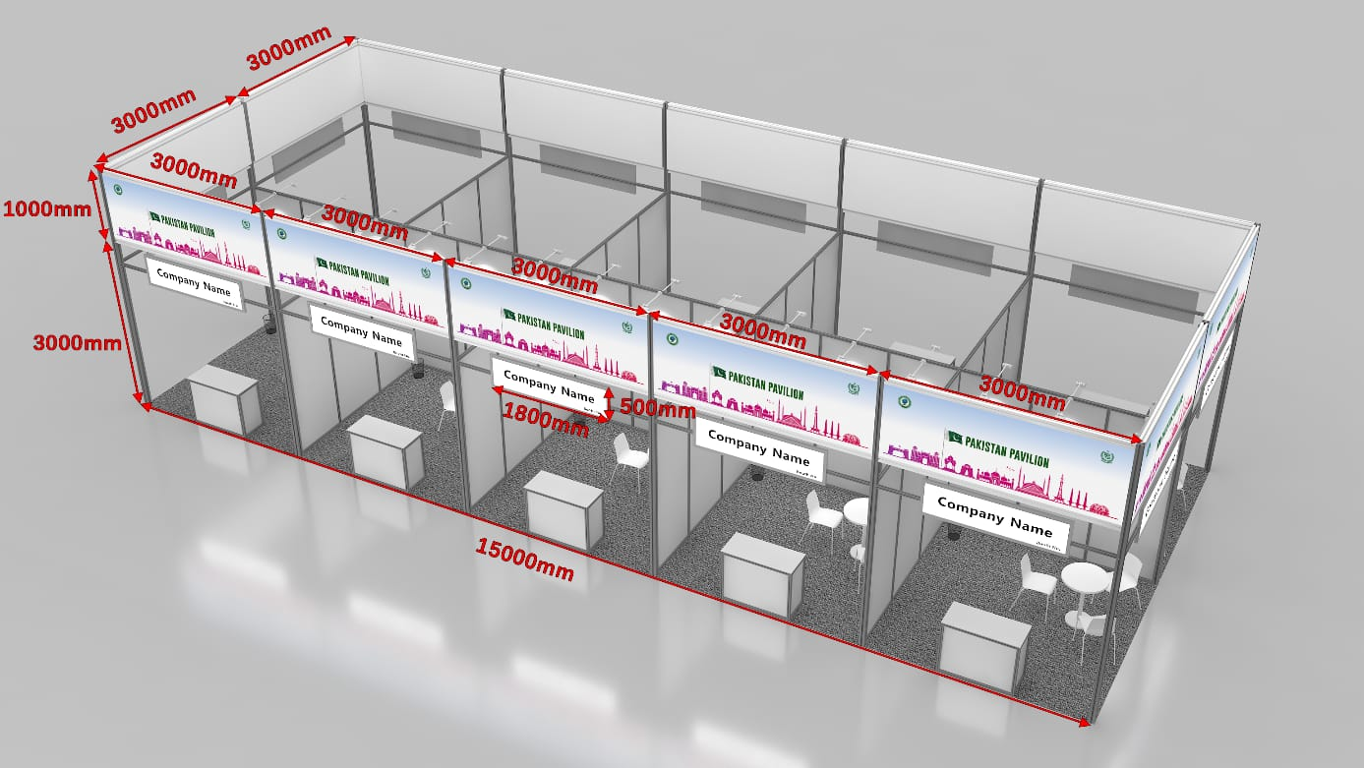
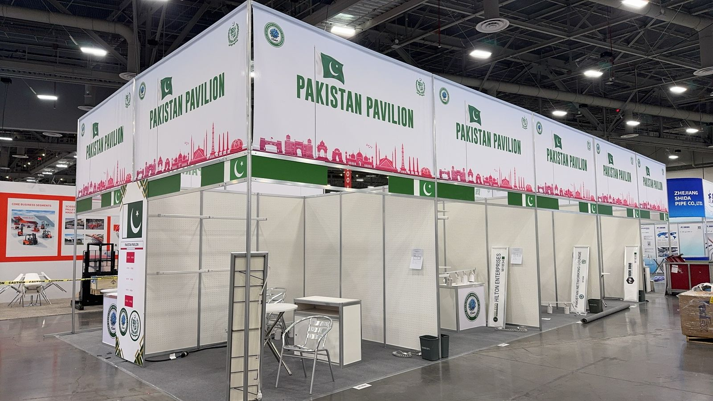
Annexure 1
